Team 10 - The Veil

What's new in this demo:

* This week’s demo we optimized the dialogue event, implement the tutorial dialogue in the game.
* Raven has the new animations of walking and jumping, the teleport and veil jump animation are waiting in asset.
* Updated Eastern temple style background music in the game. We also fixed the issue with audio cutting out. (Jump noise has also been softened, as feedback noted it became jarring after a while)
* Soundtrack now warps and normalises as you traverse planes (aware that the speed of this currently requires adjustment.)

Current controls:

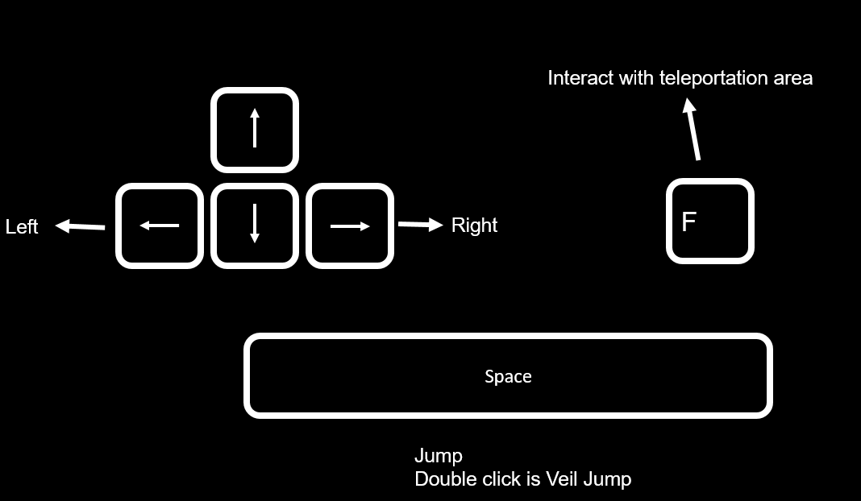

Known issues and bugs:

* Some of the teleport platform are not set for the appropriate condition, if the player is touching the teleport platform and presses ”F”, the player and platform will teleport to a strange place and this will break the game.

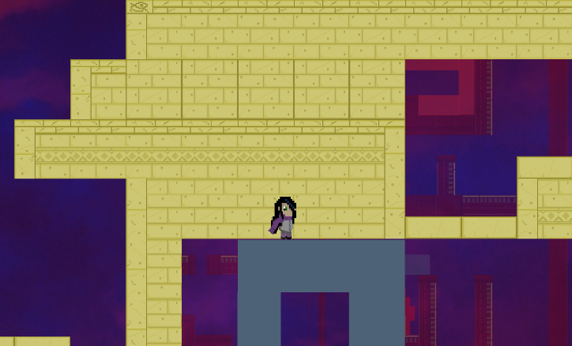

* The lever sprite is currently invisible.
* The game can be completed before finishing the level by jumping at the start of the game
* Dialogue will occasionally run over the image, and will sometimes trigger when it’s not supposed to
* At the start of the game, must set graphics quality into Ultra, otherwise some game mechanics will not work.

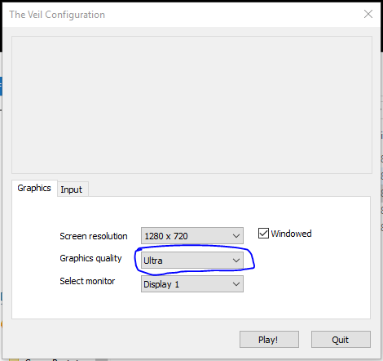

Future plan:

* Testing, find out the bugs and plan the solution.
* Fixing bugs.
* Finish implementing art and sound work.
* Adding environmental ambience to the soundtrack (will give player a greater sense of place and soften the harshness of SFX such as jumping and enemy units.)
* **See emailed ‘Proposed Future Implementation’ document**